SOFTWARE ENGINEERING AND PROJECT MANAGEMENT
4. Software Risk, Configuration Management
4.1 Risk Identification, Risk Assessment, Risk Projection, RMMM Software Configuration management, SCM repositories, SCM process Software Quality Assurance Task and Plan, Metrics, Software Reliability, Formal Technical Review (FTR), Walkthrough
PAST QUESTIONS:
- Illustrate the SCM process. (M23)
- What is Risk management? Discuss Common sources of risk in IT projects? (M23)
- Describe the details of FTR and Walkthrough. (M23, D23)
- Illustrate the SCM process of Software quality management. (D23)
- What is Risk management? Discuss RMMM plan for risk management. (D23)
- Identify any two Risks in online examination System. Perform risk assessment and prepare RMMM Plan for any one risk. (M24)
- Short note on FTR. (M24)
- Short note on SCM process. (M24)
- Explain formal technical review. (D24)
- Explain software quality management with QA and QC. (D24)
- Discuss different categories of risk and you are the project manager for a major software company. You have been asked to lead a team that’s developing “next generation” word processing software. Create a risk table for the project. (D24)
- Discuss Software configuration management. (D24)
NOTES:

*Risk Management process :-
“Risk is an uncertain future event with a probability of occurrence and potential for loss.”
Risk Management is an important part of project planning activities.
It involves identifying and estimating the probability of risks with their order of impact on the project.
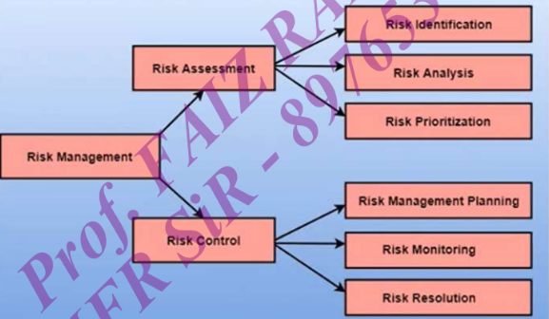
- Risk Assessment –
It is the process of identifying, analyzing and evaluating potential risks that could impact a software project's success.
- Risk Identification – The project organizer needs to anticipate the risk in the project as early as possible so that the impact of risk can be reduced by making effective risk management planning.
Types of risk which can affect the software project:
- Technology risks: Risk that assume from Software or Hardware technologies that are used to develop the system.
- Requirement risks: Changes to customer requirement & process of managing the requirement change.
- Estimation risks: Management of estimation resources required to build the system.
- Risk Analysis & Risk Prioritization - During the risk analysis process, you have to consider every identified risk and make a perception of the probability and seriousness of that risk.
The probability of a risk can be categorized as:
Very Low (0-10%): tolerable risk (no harm)
Low (10-25%): Low risk
Moderate (25-50%): Medium risk
High (50-75%): High risk
Very high (+75): Intolerable risk
- Risk Control –
It is the process of managing risks to achieve desired outcomes.
- Risk Planning - The risk planning method considers each of the key risks that have been identified and develop ways to maintain these risks.
Three main methods to plan for risks management:
- Avoid the risk: This may take several ways such as discussing with the client to change the requirements to decrease the scope of the work, giving incentives to the engineers to avoid the risk of human resources turnover, etc.
- Transfer the risk: This method involves getting the risky element developed by a third party, buying insurance cover, etc.
- Risk reduction: This means planning method to include the loss due to risk. For instance, if there is a risk that some key personnel might leave, new recruitment can be planned.
- Risk Monitoring – This is an ongoing process throughout the project and requires continuous evaluation and assessment of potential risks.
- Risk Resolution – This process ensures that the project stays on track and risks are controlled. The effectiveness of risk resolution depends on the accuracy of risk identification, analysis and planning of risk solving.

*RMMM :-
A risk management technique is usually seen in the software project plan. The RMMM can be divided into Risk Mitigation, Monitoring, and Management Plan (RMMM).
The Project manager generally uses this RMMM plan as part of the overall project plan.
In some software teams, risk is documented with the help of a Risk Information Sheet (RIS).
RIS maintain Risk ID, Date, Impact, Description, Avoidance, Current status, etc.
This RIS is controlled by using a database system for easier management of information i.e. creation, priority ordering, searching, and other analysis.
- Risk Mitigation –
Risk Mitigation is a technique for avoiding risks (Risk Avoidance).
Its is a proactive approach. Applies before the risk is generated.
Steps for mitigating the risks as follows:
- Finding out the risk.
- Removing causes that are the reason for risk creation.
- Controlling the corresponding documents from time to time.
- Conducting timely reviews to speed up the work.
- Risk Monitoring –
Risk Monitoring is an ongoing active process used to track a project’s progress.
It is performed by Project manager.
Objectives of Risk Monitoring:
- To check if predicted risks occur or not.
- To ensure proper application of risk avoidance are applied or not.
- To gather information for future risk analysis.
- To determine which risk generates which problems throughout the project.
- Risk Management –
It assumes that the mitigation activity failed and the risk is a reality.
It is a reactive approach. Applies after the risk is generated.
This task is done by Project manager when risk becomes reality and causes severe problems. If the project manager effectively uses project mitigation to remove risks successfully then it is easier to manage the risks. 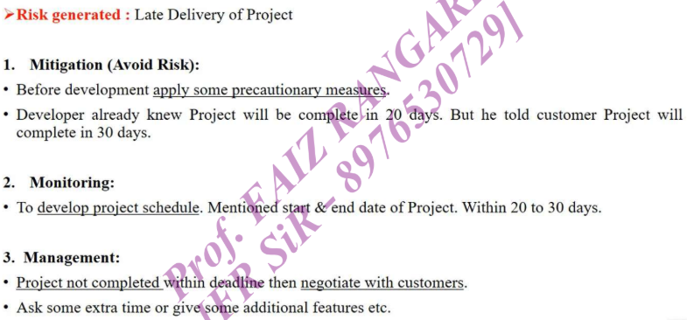

*SCM :-
Software Configuration Management (SCM) is a process that manages and controls changes to software throughout their lifecycle, ensuring consistency, traceability, and stability.
SCM is a process to systematically manage, organize and control changes in documents, code and other entities during the Software Development Life Cycle.
The primary goal is to increase productivity with minimal mistakes.
Following are the steps of SCM process:
  - Planning & Identification –
In this step the scope of the software system is determined. This is accomplished by conducting meetings and brainstorming sessions with the team.
Identifying items such as specifications, requirements, modules and schedule times.
It includes identifying details of why, when and what changes will be made and planning of who will be in charge of making them.
  - Version Control –
The aim of this step is to control the alteration and modification done to the project.
It handles different version of configuration objects that are generated during the software process.
It also focuses on developing way to track the hierarchy of different versions of the software.
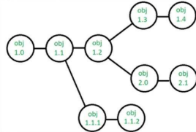
  - Change Control –
This method is used to ensure that any changes that are made are consistent with the rest of the project.
The team send changes to the Software Configuration Manager.
Software Configuration Manager checks & examine the overall impact on the project due to the changes proposed by the team.
If the impact due to change is positive then all necessary changes are implemented, if it is denied then the reason will be explained.
  - Configuration Auditing –
The audit confirms the completeness, correctness and consistency of the modified items in the SCM system.
This process is used to ensure that application will develop as per the project plan and test/verify the application as per scope.
It ensures what is built is what is delivered.
  - Reporting –
It provides an accurate status and current configuration data to developers, testers, end users, customers, and stakeholders.
It develops some application related document like user manual, installation process guide, configuration guide, do’s and don’t do’s etc.
Importance of SCM –
- SCM ensures that the changes to software system are properly planned.
- It helps teams to collaborate & coordinate their work.
- It manages & track different version of the system.
- It improves quality and reliability of software system as well as increases efficiency and reduce the risk of errors.
*SCM Repository :-
SCM repository is a set of control process & data structure that allow software team to manage change in effective manner.
SCM repository functions: Data sharing, information sharing, Data integration, Tool integration

*Formal Technical Review (FTR) :-
Formal Technical Review (FTR) is a software quality control activity performed by software engineers. It is used to evaluate the quality and correctness of technical work products.
It is an organized, methodical procedure for assessing and raising the standard of any technical paper, including software objects. Finding flaws, making sure standards are followed, and improving the product or document under review's overall quality are the main objectives of a formal technical review.
Although FTRs are frequently utilized in software development, other technical fields can also employ the concept.
Objectives of formal technical review:
- Detect Identification: Identify defects in technical objects by finding and fixing mistakes.
- Quality Assurance: To ensure high-quality deliverables.
- Risk Mitigation: To stop risks from getting worse.
- Knowledge Sharing: Encourage team members to work together and build a common knowledge base.
- Learning and Training: Give team members the chance to improve their abilities through learning opportunities.

* Walkthrough :-
A walkthrough involves the author of a document or software product guiding a group of peers, managers, and team members through it, explaining the content and soliciting feedback. This informal review process aims to gather information, facilitate understanding, and identify potential errors or areas for improvement early in the development cycle.
Objectives of Walkthrough:
- To detect defects in developed software products.
- To fully understand and learn the development of software products.
- To properly explain and discuss the information present in the document.
- To verify the validity of the proposed system.
*Software Quality Management (SQM) :-
Software Quality Management (SQM) is a process focused on ensuring that software products meet specified quality standards and are fit for their intended purpose. It involves several activities and practices designed to improve the overall quality of software throughout its lifecycle.
Quality Assurance (QA) and Quality Control (QC) are key components of software quality management. While both aim to ensure that software meets quality standards, they focus on different aspects of the process:
1. Quality Assurance (QA): QA is a proactive process that focuses on preventing defects during the software development lifecycle. It emphasizes improving and defining processes to ensure that quality standards are met throughout the project.
Objectives:
- Ensures that the software development process is efficient and defect-free.
- Improves the process, methodologies, and practices to reduce the likelihood of defects in the final product.
2. Quality Control (QC): QC is a reactive process that focuses on identifying and fixing defects in the final product. It involves activities like testing and inspections to find defects before the software is released.
Objectives:
  - Identifies bugs or defects in the final product to ensure that the software works as intended.
  - Ensures that the software meets the required quality standards.

